**RESISTOR COLOUR CODING.**

As there are many different types of **Resistor** available we need to form of resistor colour code system to be able to identify them.

Resistors can be used in both electrical and electronic circuits to control the flow of current or to produce a voltage drop in many different ways. But in order to do this the actual resistor needs to have some form of “resistive” or “resistance” value. Resistors are available in a range of different resistance values from fractions of an Ohm ( Ω ) to millions of Ohms.

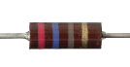

The resistance value, tolerance, and wattage rating are generally printed onto the body of the resistor as numbers or letters when the resistors body is big enough to read the print, such as large power resistors.

**The Standard Resistor Colour Code Chart**

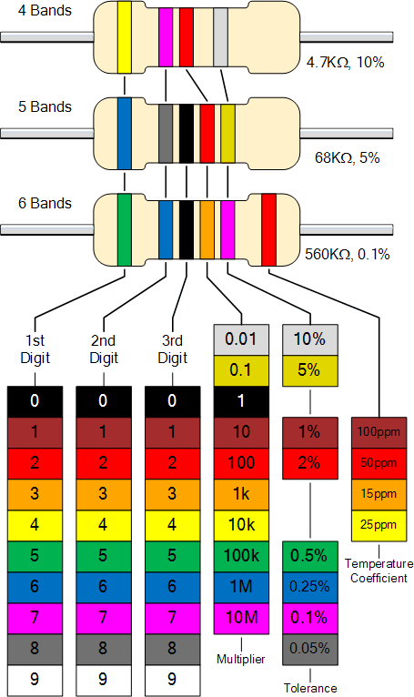

**Calculating Resistor Colour Code Values**

The **Resistor Colour Code** system is all well and good but we need to understand how to apply it in order to get the correct value of the resistor. The “left-hand” or the most significant coloured band is the band which is nearest to a connecting lead with the colour coded bands being read from left-to-right as follows:

Digit, Digit, Multiplier = Colour, Colour x 10colour  in Ohm’s (Ω)

For example, a resistor has the following coloured markings;

Yellow Violet Red = 4 7 2 = 4 7 x 102 = 4700Ω or 4k7 Ohm.

**The Resistor Colour Code Table**

|  |  |  |  |
| --- | --- | --- | --- |
| Black | 0 | 1 |  |
| Brown | 1 | 10 | ± 1% |
| Red | 2 | 100 | ± 2% |
| Orange | 3 | 1,000 |  |
| Yellow | 4 | 10,000 |  |
| Green | 5 | 100,000 | ± 0.5% |
| Blue | 6 | 1,000,000 | ± 0.25% |
| Violet | 7 | 10,000,000 | ± 0.1% |
| Grey | 8 |  | ± 0.05% |
| White | 9 |  |  |
| Gold |  | 0.1 | ± 5% |
| Silver |  | 0.01 | ± 10% |
| None |  |  | ± 20% |